Howard University
College of Engineering and Architecture
Department of Electrical Engineering & Computer Science

Large Scale Programming
Fall 2024

Midterm Exam – Part I
October 17, 2024

Part I: 50 pts. (essay questions)

Instructions:
- Submit completed exam to your github repository under package org.howard.edu.lsp.midterm

Verify that the commit(s) completed successfully

- OPEN BOOK, OPEN NOTES. THERE IS NO COLLABORATION ON THIS EXAM
- Site any and ALL references for anything obtained off the internet.

Question 1. (10 pts.)

You are reviewing the following class in a Fitness Tracking System. The class is intended to manage various aspects of a user’s fitness activities.

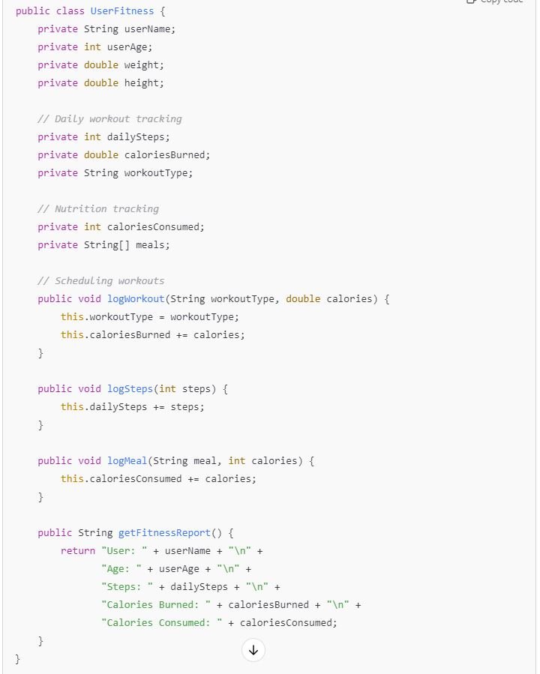

Tasks:
- Analyze the UserFitness class. Explain why this class has low cohesion. (5 pts.)

This class is low cohesion because the subclasses are loosely related and do not have one specific goal. It’s unclear what the overall goal of the class is and how the subclasses belong together.

(source: https://www.geeksforgeeks.org/software-engineering-coupling-and-cohesion/)

- Describe, in general, how you would split the UserFitness class into more cohesive classes. Your answer should not be a complete design. (5 pts.)

I would ensure each class has a single responsibility, and that responsibility connects with the other subclasses with a particular goal in mind. For example, “steps” might be a type of workout, so perhaps the “logworkout” subclass should have an option to take in steps. And the overall goal would be ensuring the person is healthy.

(Source: https://www.geeksforgeeks.org/software-engineering-coupling-and-cohesion/)

Question 2. (5 pts.)
Given the following, answer the below questions.

A university manages its students using a program that has a class Student with subclasses FirstYear, SecondYear, and ThirdYear for year-specific state and behaviors. The program has a List that contains all Students.

Should Student be a class, an abstract class or an interface? Explain your answer

Student should be an abstract class. You don’t want to create instances of “Students”, so it should not be abstract. You also want specific attributes for each year of student.

(Source: https://www.geeksforgeeks.org/difference-between-abstract-class-and-interface-in-java/)

Class slides also

- At the end of each year, the third-year students graduate and must be removed. This is done by passing the list to the following method:

void removeThirdYears(List<Students> students) {
for (Student student : students) {
try {
ThirdYear = (ThirdYear) student;
students.remove(thirdyear);
}
}
}

Why is the above method flawed? Hint: Another Arthur Riel heuristic (5 pts.)

This is flawed because you’re changing the structure while iterating over it.

Question 3. (5 pts.)
Given the following, answer the below questions.

public class BankAccount {
public String accountHolderName;
public String accountNumber;
public double balance;
public double interestRate;

public BankAccount(
String accountHolderName,
String accountNumber,
double initialDeposit,
double interestRate) {
this.accountHolderName = accountHolderName;
this.accountNumber = accountNumber;
this.balance = initialDeposit;
this.interestRate = interestRate;
}

// Exposed implementation for adding interest
public void addInterest() {
double interest = balance * (interestRate / 100);
balance += interest;
}

// Exposed implementation for deposits
public void deposit(double amount) {
balance += amount;
}

// Exposed implementation for withdrawals
public void withdraw(double amount) {
balance -= amount;
}
}

- Is BankAccount well-encapsulated? Why or why not? If so, describe what changes you would make to the class. Otherwise, state nothing. (5 pts.)

This class is not well encapsulated because fields that hold important data (account number, account name, balance, etc.,) are public, meaning they can be changed by users outside the class. To solve this, make these variables private. (Maybe also make sure user isn’t withdrawing more than current amount in account?)

Question 4. (10 pts.)
Given the following, answer the below questions.

Given:
A car manufacturer uses Java software to track current vehicles being built. The UML diagram below shows an excerpt of the current software structure. You should assume the presence of other appropriate fields and methods

Car
getTrimLevel()
Engine
accelerate()
getFuelLevel()
Base
Sports
Luxury
Electric
Petrol

Each car can be built to one of three trim levels: Base, Luxury or Sport. They can also be configured with an electric or petrol engine. At various points in the manufacturing process the customer can choose to change the trim level.

Task:
- Explain in detail why the current structure does not support this. (5 pts.)

- Business requirements and database requirements often change at different rates. For instance, changes to the business logic of how cars or bank accounts are modeled may not affect how data is persisted.

does not allow changes to car trim level because
-change the trim level and then need to change attributes
-the logic for managing car attributes and dynamically updating the trim is likely embedded within the `Car` class.
-prevents easy changes or extensions to the trim-level feature, making it hard for the software to respond to changes requested by the customer during the manufacturing process.
-a class should be open for extension but closed for modification.
Clean Code: A Handbook of Agile Software Craftsmanship"** by Robert C. Martin:

- Describe how to refactor the structure to allow trim-level change for a car to dynamically change. Hint: How would you modify Car to use composition to solve the problem? (5 pts.)

Question 5. (5 pts.)
Suppose you are about to code a particular class and find that you have written another class with nearly the functionality that you now are developing. This means that the two classes in large parts contain the same code, but in smaller parts have different code. Explain in detail why this may be a problem and how to solve it. Give your answer in terms of Arthur Riel’s design heuristics.

This may be a problem because if changes need to be made, they must be made in both classes. It can also be harder for readers to understand if similar things are happening in two different places with no connection, violating Don’t Repeat Yourself Principle. To solve this, use inheritance. The similar class can be a subclass that inherits the similar methods or attributes from the overarching class.

(Source: https://www.geeksforgeeks.org/dont-repeat-yourselfdry-in-software-development/)

Question 6. (5 pts.)
Suppose we need to store instances of the classes Car and BankAccount in a database. To obtain low coupling it may seem as if the functionality to save an instance should be in precisely those classes, since they have the information that shall be saved. Why is it unwise to place the database calls there?

Question 7. (5 pts.)
Given a set of requirements, what conditions must be met to make it appropriate to create a new class hierarchy using inheritance? Neither superclass nor subclass exist before, the question is about designing a new class hierarchy.

The “isa” rule (does this thing fall under broader scope of things). Shared methods/attributes, similar behaviors. Also the methods should be overridable so the subclasses in the hierarchy can overwrite as needed to fit the needs of that subclass. Should not be overly complex. Encapsulation, and superclass should be relatively stable (unchanged).

(Class slides)

Question 8. (2.5 pts.)
Describe the difference between inheritance and composition why would you choose one over the other.

Inheritance defines a family of classes. The top member is the “super class”, with lower level “subclasses”. Subclasses can add/extend to the superclass and also redefine/override the implementations of operations in the superclass. Composition is more of a “black-box” reuse as opposed to the “is a”/white box reuse of inheritance, however both are for re-using functionalities. Composition models a “has a” relationship. If it “is a special kind of” rather than “is a role played by”, needs to transmute, or within Problem Domain, doesn’t specialize role/transaction/device, inheritance doesn’t fit. Composition would be better. Vice Versa for inheritance. For inheritance, also need to extend rather than override, and doesn’t extend to utility class.

Question 9. (2.5 pts.)
Explain the meaning of cohesion and describe whether low or high cohesion is better.

High cohesion means elements/classes are focused on a clear purpose and related. Low cohesion means loosely related and serving multiple purposes.

High cohesion is better because the code is easier to read, work with, and reuse.

https://www.geeksforgeeks.org/software-engineering-differences-between-coupling-and-cohesion/

